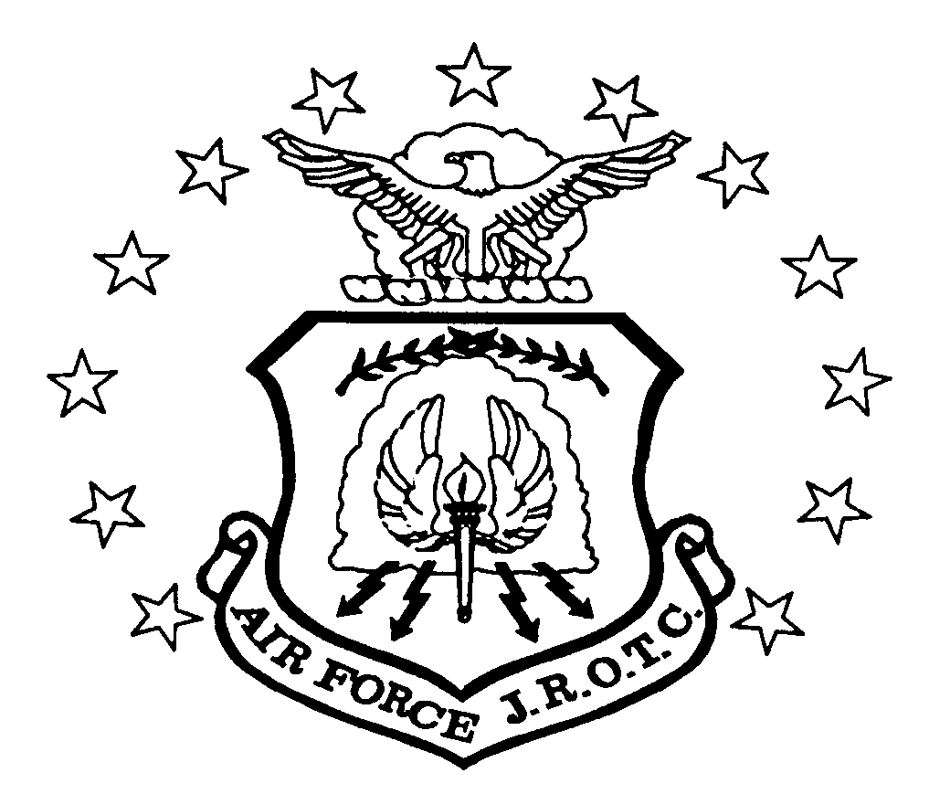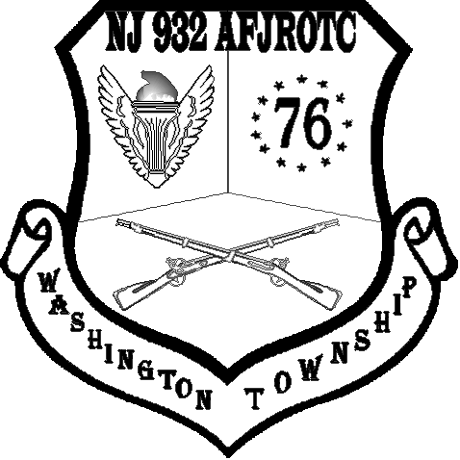TELEPHONE: 856-589-8500 Ext 7247/7265/7266

DEPARTMENT OF AEROSPACE SCIENCE
NJ 932ND AIR FORCE JUNIOR ROTC WING
WASHINGTON TOWNSHIP HIGH SCHOOL
529 HURFFVILLE-CROSSKEYS ROAD
SEWELL, NJ 08080-2746

DATAFAX: 856-256-9148
EMAIL: NJ-932@AFJROTC.COM

1September 2009

MEMORANDUM FOR ALL CADETS, PARENTS and GUARDIANS 17 August 2020

FROM: Senior Aerospace Science Instructor (SASI)

SUBJECT: SYLLABUS 2020-2021 Aerospace Science (AFJROTC: Air Force Junior Reserve Officer Training Corps)

COURSE TITLE: Aerospace Science (AS) I & Leadership Education (LE) II Course
(Air Force Junior ROTC) A five credit, Practical Arts Course (1st, 2nd, 3rd year cadets)
AS IV Management of Cadet Corps, LE IV Principles of Management (4th year cadets, officers only)

TEXTBOOKS: Milestones in Aviation History, Chapters 1, 3, 5, 7 (Text appears on Powerschool/Schoology)
Cultural Studies: An Introduction to Cultural Awareness, Chapters 3, 6 (Text appears on Powerschool/Schoology) Traditions, Wellness, and Foundations of Citizenship, Chapter 1 (Text appears on Powerschool/Schoology)
Communication, Awareness, and Leadership, Chapters 1, 3, 5, 7 (Text appears on
Powerschool/Schoology)
Fundamentals of Management (Leadership Education IV), Chapters 1-8 (Text appears on Powerschool/Schoology)
Wellness (Handouts)
Drill and Ceremonies, AFMAN 36-2203 (Text and Workbook)
Cadet Guide, 2020-21 Handbook (appears on school JROTC webpage) and Workbook

COURSE CONTENT & OBJECTIVES: Learn “Life Skills” that will enable you to succeed in high school, college, and career. Understand the development/evolution of flight from early 20th century to present day. Gain global perspective in cultural studies by studying Africa and Europe. Understand effective communication, team building, and problem solving. Understand the organization of JROTC, health/nutrition, and the foundations of citizenship. Gain life balance by studying and incorporating all aspects of wellness. 4th year cadets: Understand & demonstrate proper planning, decision making, organizing, and leading JROTC teams/flights/classes/activities. Serve the JROTC corps of cadets as officers of senior command staff. All: Be able to study and practice the concepts of discipline, respect, responsibility and teamwork. Learn the concepts of orderliness and precision through drill and ceremonies. Understand the role of the military in American society. Know how to care for/respect, the Flag of the United States of America.

INSTRUCTORS: The Aerospace Science Instructors (ASIs), Lt Col Lumpkin, MSgt Hood, and MSgt Harris are retired from the Air Force. They are state-certified Aerospace Science (Military Science) teachers. They were hired by, and work for, the Washington Township Board of Education. They are required by law to wear their Air Force uniform when teaching Junior ROTC.

Aerospace Science is a five-credit course: which fills the practical art high school graduation requirement. THERE IS ABSOLUTELY NO MILITARY OBLIGATION ASSOCIATED WITH TAKING HIGH SCHOOL AIR FORCE JUNIOR ROTC. Enrollment in Junior ROTC for three or four years MAY qualify you for advanced rank and pay if you decide to join ANY branch of the military service. Taking Junior ROTC WILL NOT INTERFERE with any extra-curricular activities.

EVALUATION TECHNIQUES:
Tests, quizzes, homework assignments and participation. RESEARCH PROJECT: Build and fly model airplanes.
Individual and group performance in drill and ceremonies
Personal bearing, behavior, attitude and discipline
Accepting responsibility and the consequences of your actions
Teamwork in problem solving exercises
Uniform Wear and Grooming Standards
Wellness Activities

**Cadets are expected to bring their required text (if not on laptop), a notebook, a pencil and a pen (black or blue ink) to all classes unless instructed otherwise. Aerospace Science (AS)/Leadership Education(LE), Wellness, Uniform Inspection (LE), Leadership Laboratory. A weekly lesson plan is posted on JROTC website and the classroom bulletin board on the last school day of the week.

GRADING: WEAR OF THE UNIFORM IS A CRITICAL COMPONENT OF PASSING THE JROTC COURSE!!!
30% of your grade is based upon AFJROTC Class A, B, C, and ABU uniform wear; 30% of your grade is based upon Aerospace Science and Leadership Education tests; 20% of your grade is based on participation in wellness activities/wear of the wellness uniform (Class D); 10% of your grade is based on homework; 10% of your grade is based upon Leadership Education (Drill).
.
A Health Waiver is required for all cadets to participate in any physical activity (i.e. fitness, Drill, Wellness)

PROMOTIONS: Superior performance leads to advancement in rank and selection for positions of increased responsibility. This program is run by the cadets. Minimum requirements for promotion are an average of 78% or higher. Other factors affecting promotion are classroom performance, adherence to the student code of conduct, and participation in Junior ROTC activities.
**NOTE: Failure to turn in your homework on time will adversely affect your grade and your chances for promotion. Failure to wear your uniform when required can cause you to fail the course (as well as diminish your chances to promote). Cadets are considered for promotion at the end of each marking period.

UNIFORM WEAR: Every cadet will be issued an Air Force uniform free of charge. We provide all applicable uniform items. Each cadet will be issued a v-neck undershirt to wear with the Class A, B, and C uniforms. Cadets are expected to wear their uniform to school and all day in school, at least once a week, either in person or virtual (on a day when wellness uniform is not required). We will pay for initial alterations. Cadets are inspected and given a grade commensurate with their conformance with Air Force grooming/iniform wear standards. Uniform wear and appearance will be covered in class. Every cadet is expected to be in Class-A uniform during the week of September 28th-October 2nd 2020. Students will also be issued physical training (PT) gear. They are required to wear this uniform for wellness days along with sneakers (not slides, sandals, dress shoes, or boots). Failure to wear any component of the PT uniform will result in a grade of zero for wellness day. Extenuating circumstances will be considered when brought to the attention of the ASI’s, for example an emergency which affected the ability to wear their Class A uniform or PT gear.

AWARDS/DECORATIONS: Cadets may be awarded national medals and/or ribbons for performance “above and beyond” normal classroom activities. There are opportunities to get involved in leadership and service projects throughout the school year. The awards ceremony is held Wednesday evening, May 5th. There are more than 30 awards given out. This ceremony was conducted virtually for school year 2019-20.

FIELD TRIPS: We normally take field trips each year (examples are aircraft orientation flights, tours of Air Force Bases, museums, Civil Air Patrol flights Army/Navy Football Game). Naturally, only cadets in good standing in Junior ROTC are eligible to go on field trips. When space is limited, a cadet’s grade and rank are considered. Cadets who are failing any class (to include ROTC), do not turn in ROTC homework, and/or do not wear the uniform are not considered. COVID-19 precautions may affect our ability to take field trips. AFJROTC/school policies will dictate the direction our program takes regarding field trips.

CO-CURRICULAR ACTIVITIES: We have a Drill Team, Color Guard, Model Rocketry Club and Model Airplane Club. These are voluntary, after school activities. Active Drill Team/Color Guard members can earn a WTHS Varsity or JV Letter.
We also have a “Dining Out” on November 17th, a “Military Ball” on January 29th, a Drill Competition on February 27th, a “Final Awards Ceremony” on May 5th, and Military Hall of Honor on a date in May TBD. Although not mandatory events, cadets are strongly encouraged to attend.

CLASSROOM RULES
DO NOT be late for class DO NOT enter ASI’s office without permission DO NOT cut through the classroom to go to LG
DO NOT sit in the Cadet Commander’s chair DO NOT place book bags on the table DO NOT touch another cadet
DO NOT use cell phones, etc. in the classroom DO bring laptop/books to class DO bring a pencil/pen to class
DO turn in your homework on time DO wear your uniform when required DO come to class ready to participate
DO follow the instructions of Flight Commander & Flight Sergeant DO raise your hand & be recognized before speaking
DO go to the restroom before coming to class DO adhere to WTHS school dress code & code of conduct
DO show Respect to ASIs and fellow cadets DO practice safety/social distancing

COMMITMENT: You selected Aerospace Science (AFJROTC) after receiving a thorough briefing on what the course is like. Once enrolled, you are committed to adhere to the rules, regulations, policies and procedures established by this program for the entire school year. We, the instructors, have committed ourselves to fair treatment and equal opportunity for all, and, also to give you the tools (Life Skills) that will make you better students, responsible citizens and leaders in the years to come.

BETH ANN LUMPKIN, M.A., Lt Col, USAF (Retired)
Senior Aerospace Science Instructor
Chair, Department of Aerospace Science

